**JUnit Testing Exercises**

**Exercise 1: Setting Up Junit**

***SampleTest.java***

import org.junit.Test;

import static org.junit.Assert.*;

public class SampleTest {

@Test

public void testAddition() {

assertEquals(4, 2 + 2);

}

@Test

public void testSubtract() {

assertEquals(10, 7+3);

    }

}

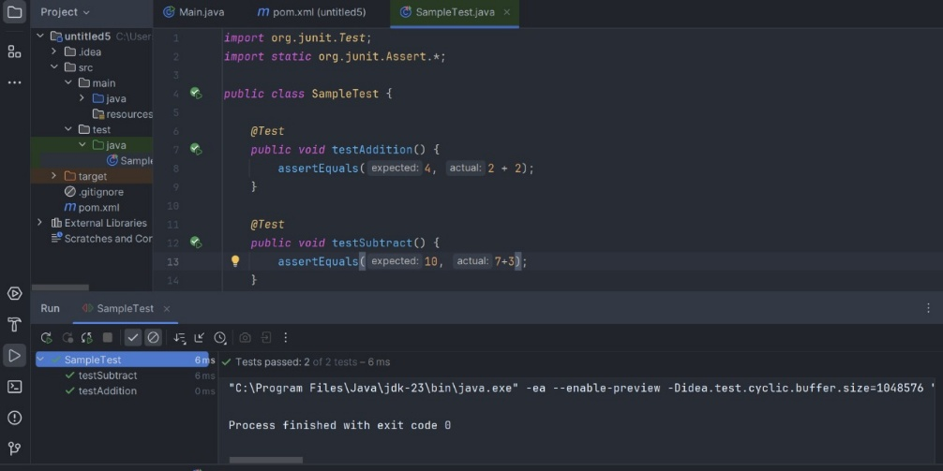**Output:-**

**Exercise 3: Assertions in Junit**

***AssertionsTest.java***

import org.junit.Test;

import static org.junit.Assert.*;

public class AssertionsTest {

@Test

public void testAssertions() {

assertEquals(5, 2 + 3);

assertTrue(5 > 3);

assertFalse(5 < 3);

assertNull(null);

assertNotNull(new Object());

    }

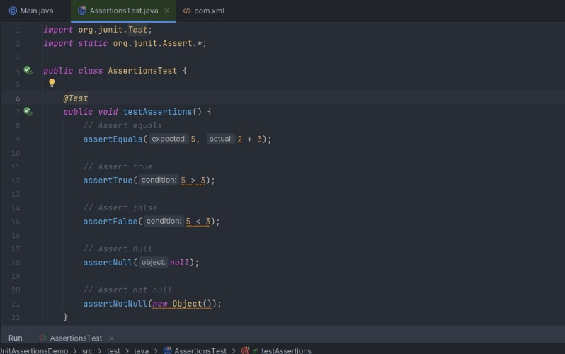}

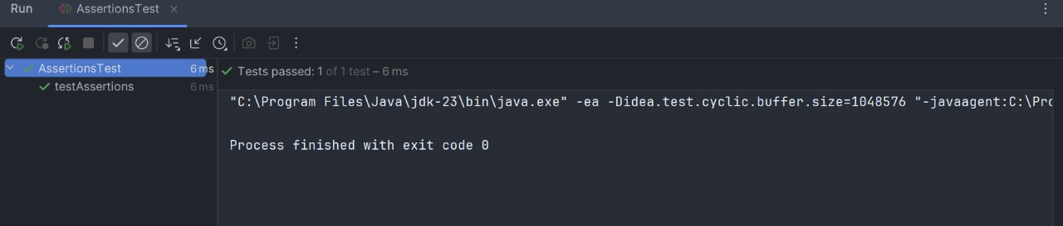**Output :-**

**Exercise 4: Arrange-Act-Assert (AAA) Pattern, Test Fixtures, Setup and Teardown Methods in JUnit**

***CalculatorTest.java***

import org.junit.After;

import org.junit.Before;

import org.junit.Test;

import static org.junit.Assert.*;

public class CalculatorTest {

private Calculator calc;

@Before

public void setUp() {

calc = new Calculator();

System.out.println("Setup: Calculator created");

}

@After

public void tearDown() {

System.out.println("Teardown: Calculator removed");

calc = null;

}

@Test

public void AddNumbers() {

int result = calc.add(5, 3);

assertEquals("Expected result of 5 + 3 is 8", 8, result);

}

@Test

public void SubtractNumbers() {

int result = calc.subtract(5, 3);

assertEquals("Expected result of 5 - 3 is 2", 2, result);

}

}

***Calculator.java***

public class Calculator {

public int add(int a, int b) {

return a + b;

}

public int subtract(int a, int b) {

return a - b;

    }

}

